See The sound

Open the Sinic Visualizer and see the spectrum

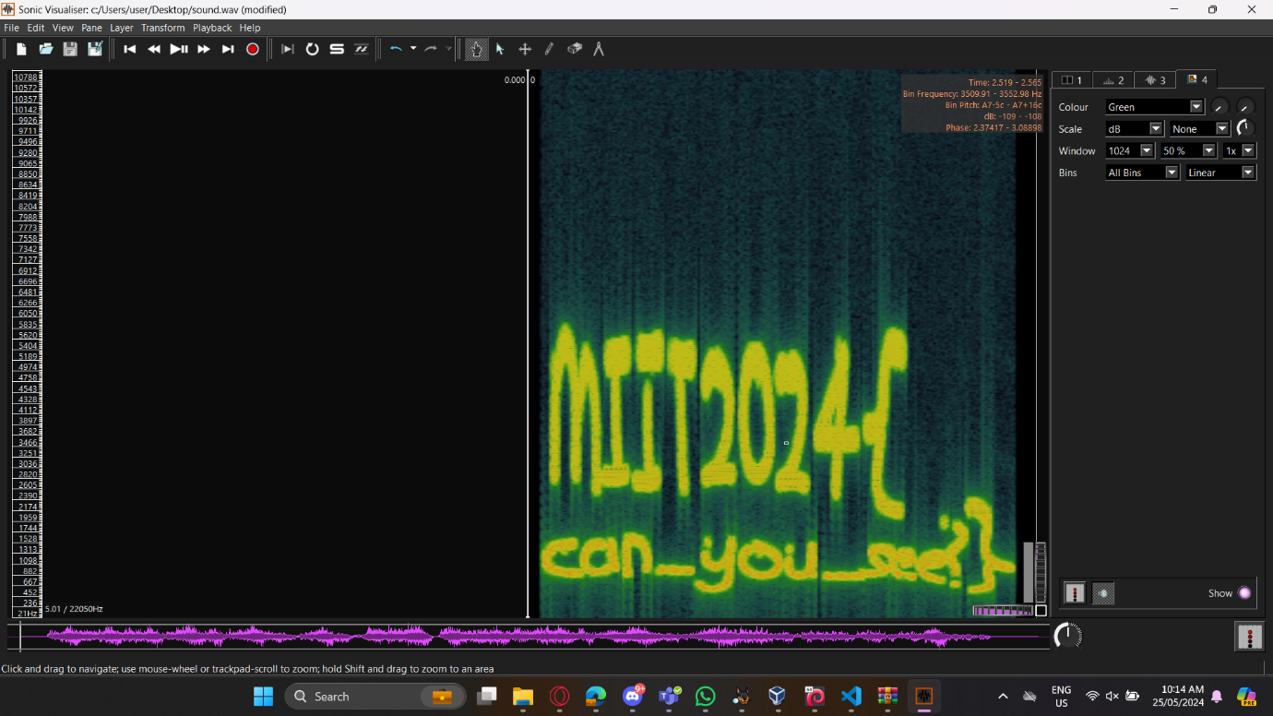  
  
SimpleRSA

Ask chatGPT to reverse it and give it the information needed  
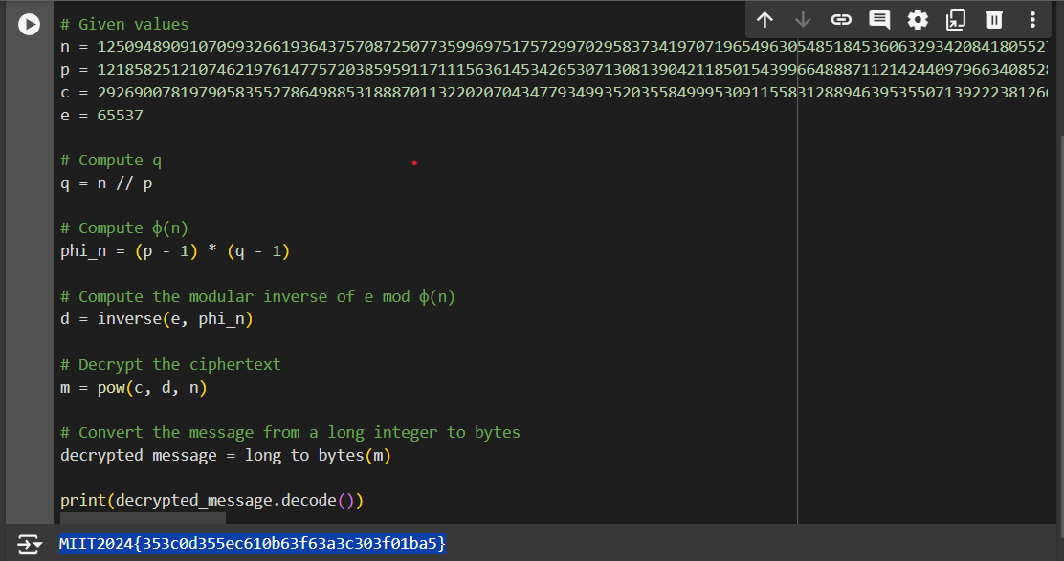

MISC  
Flag Town

Open the VBA by using GBA emulator, asking around town and they will give the clue at the town sign

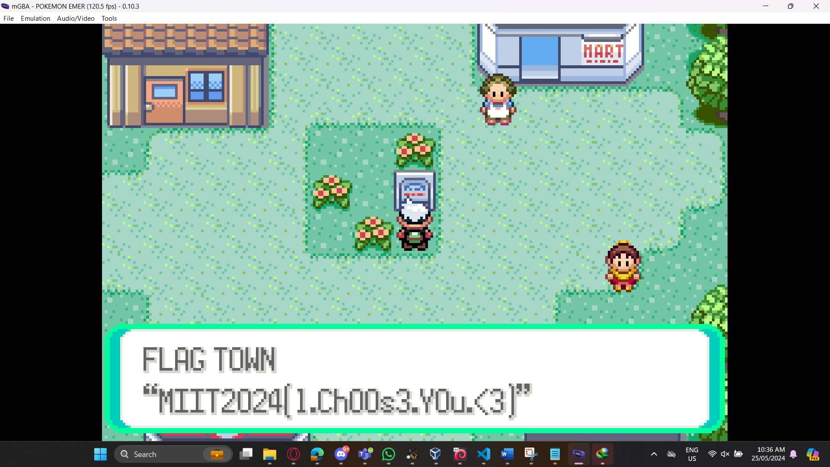

TOO MANY FLAG

Open cybechef and use the magic filter

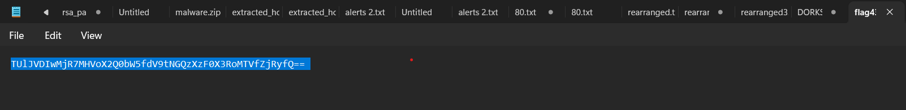

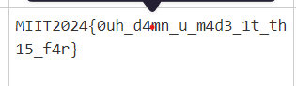

SPAM

Use the password given by the clue which is miit2024, and then put it in aperisolve  
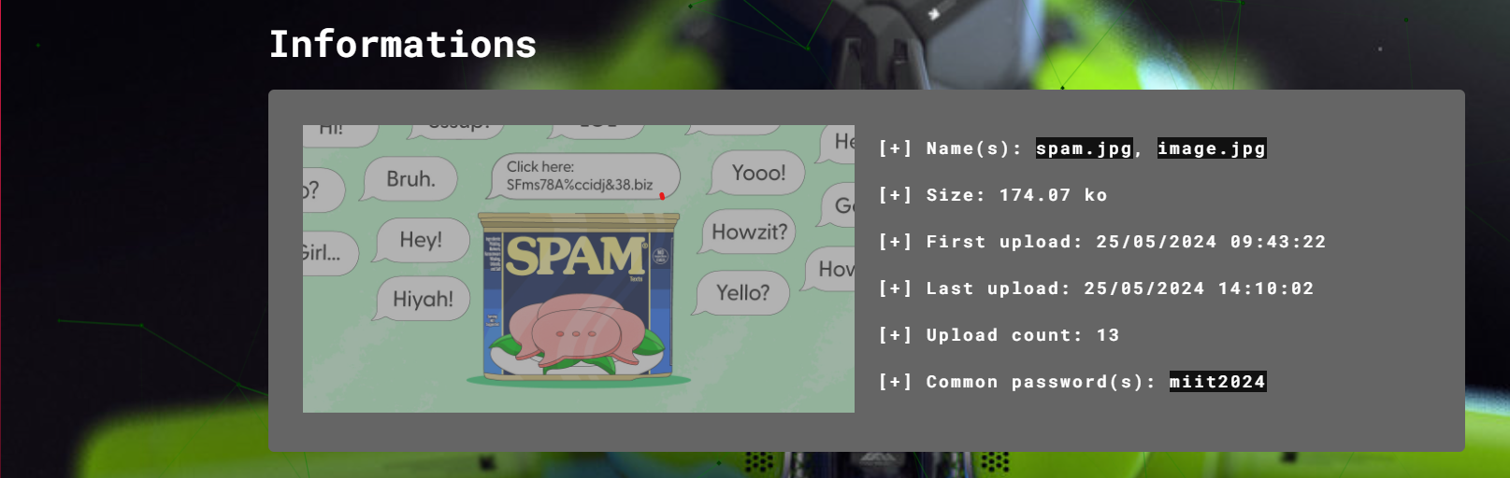

It will give the encrypted.txt

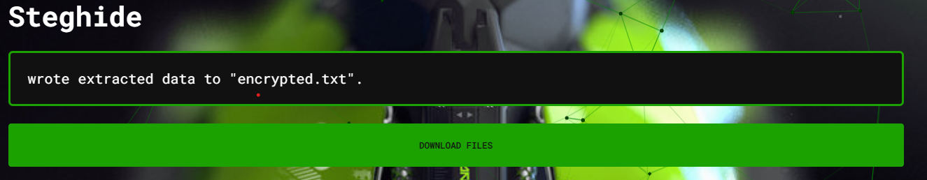

It wil give this long text, so by using many decipher tools, the suitable one is textmimic

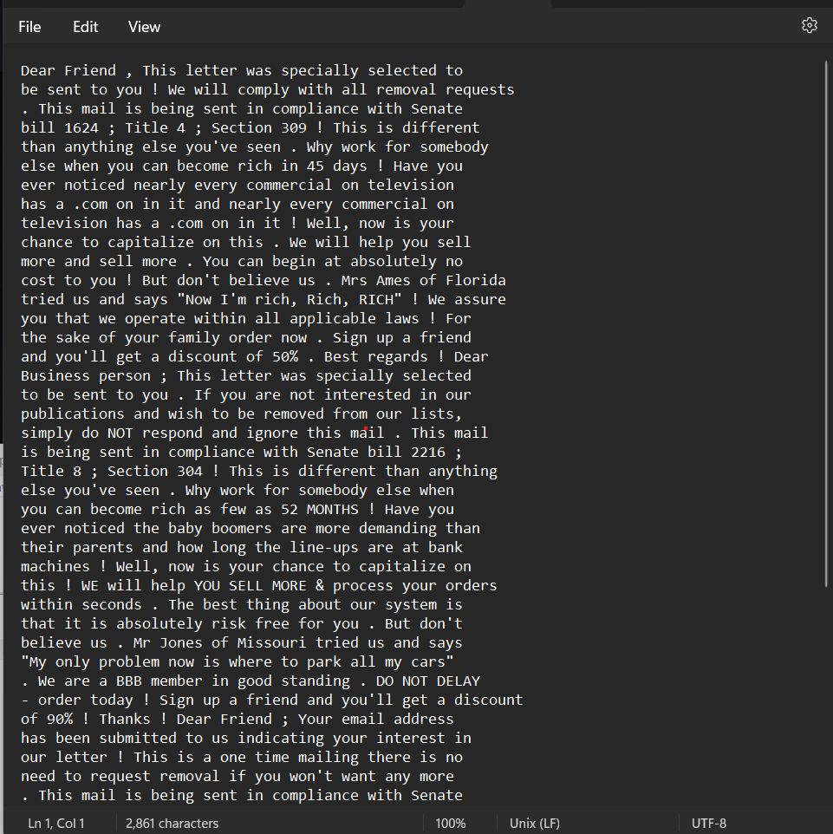

Decode it and it wil give this flag  
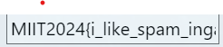

Windows Classy

By using online exiftool, we can see that thete is zip in the docm file

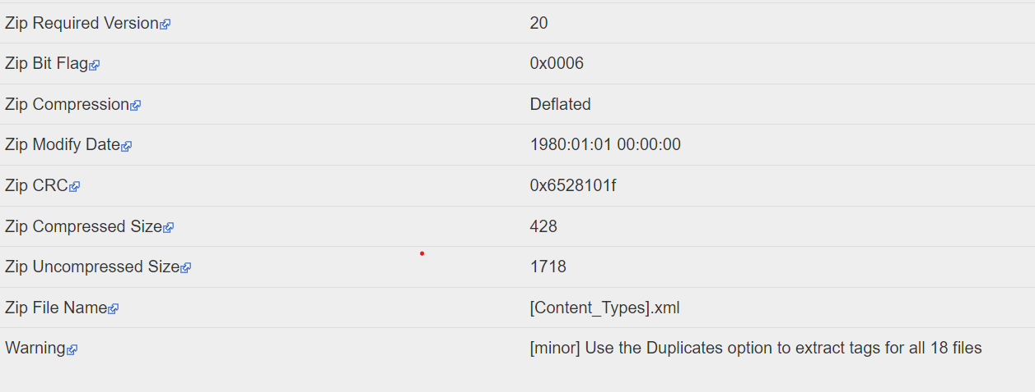

Analyze it by using ole tools  
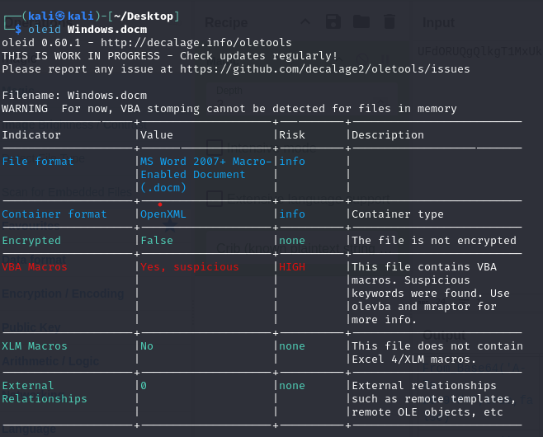

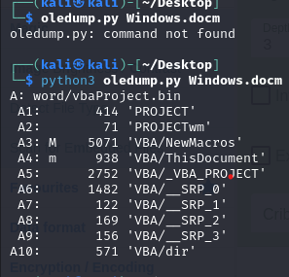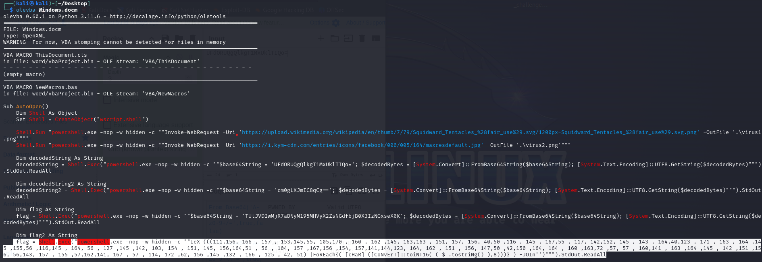

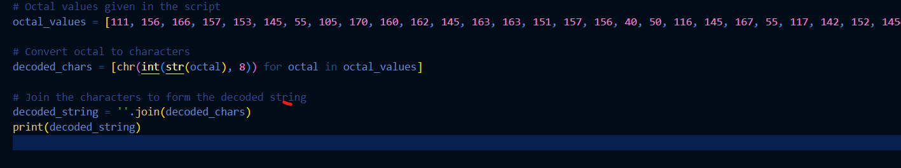





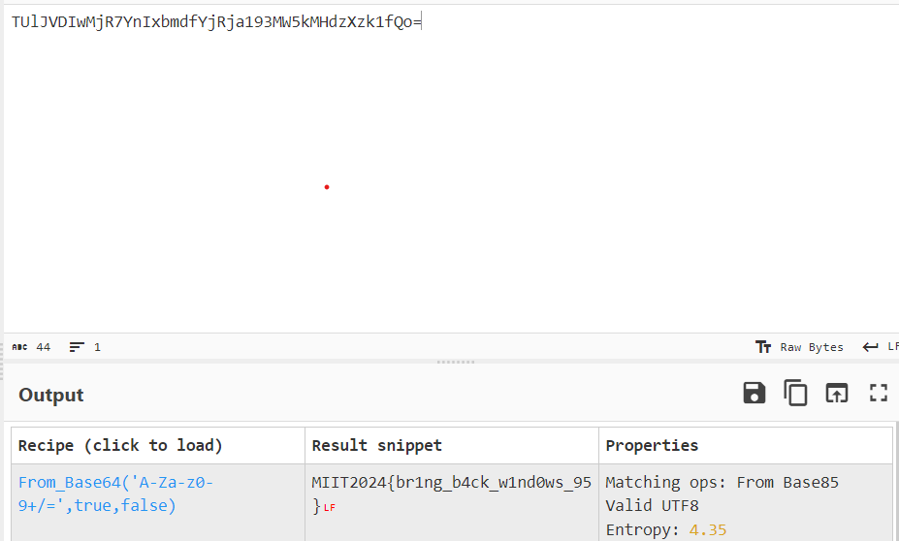

SPLIT

Using the stesgolve tools we can combine the image

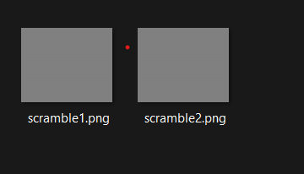



The flag is : MIIT2024{pixelated}

TOO MANY FLAG

There are many flags in there, but we can easily find it by using the size file, most of the file is the same, but some of it is different, by using tears and blood, I finally got it  


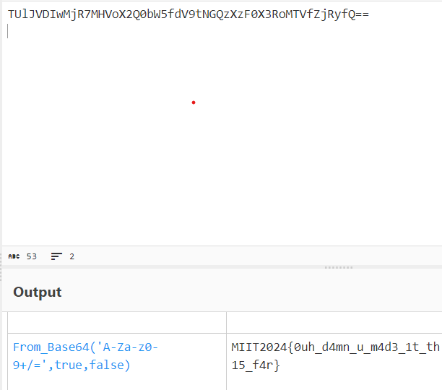

Alternate World:

Search intext:MIIT2024 in google browser  
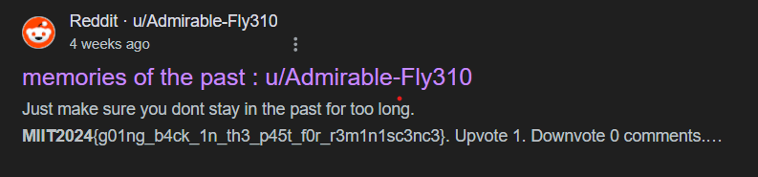

REARRANGE 1  
  
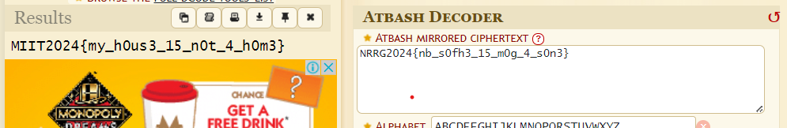  
  
REARRANGE 2:

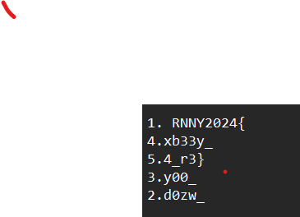

Arrange it and find the encryption  
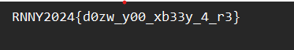  
using affine decoder  


REARRANGE 3:  
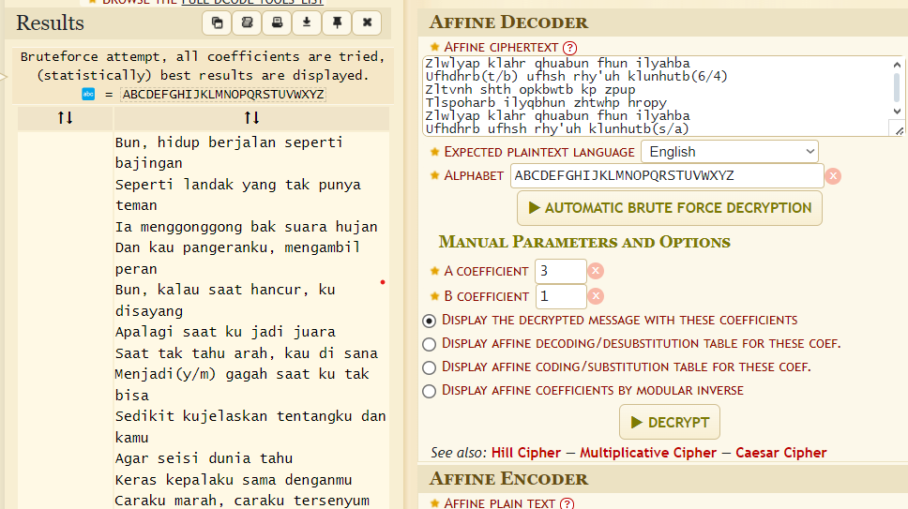  
  
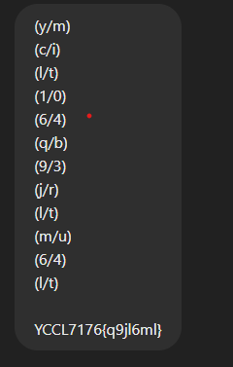  
  
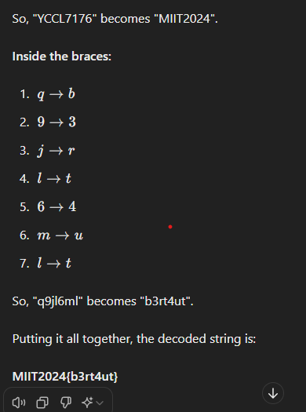

Forensics

Hidden File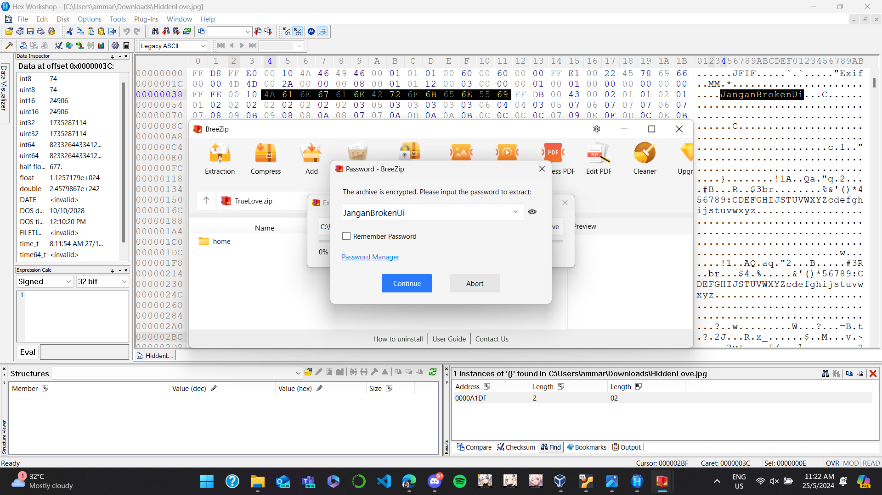

Put HiddenLove.jpg in HexWorkshop and we can found text JanganBrokenUi.

So I put it in the zip file and we will got a file called flag.jpg found the flag

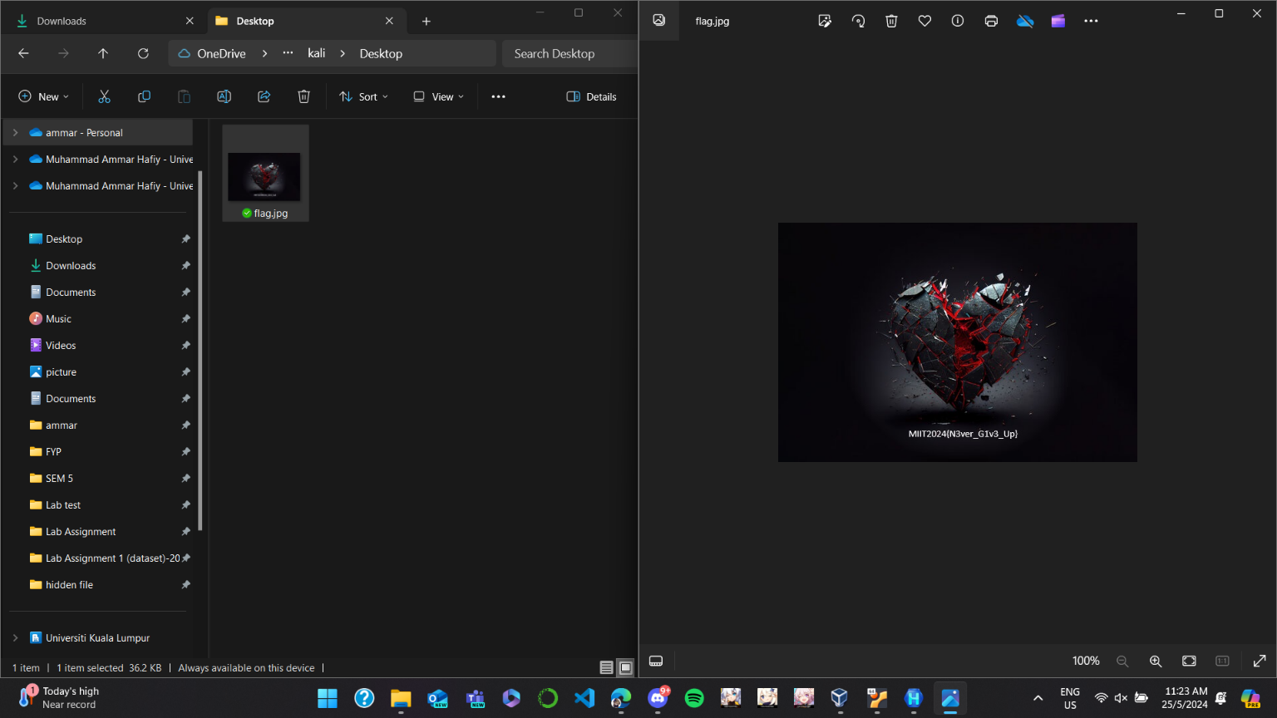

Warning Letter

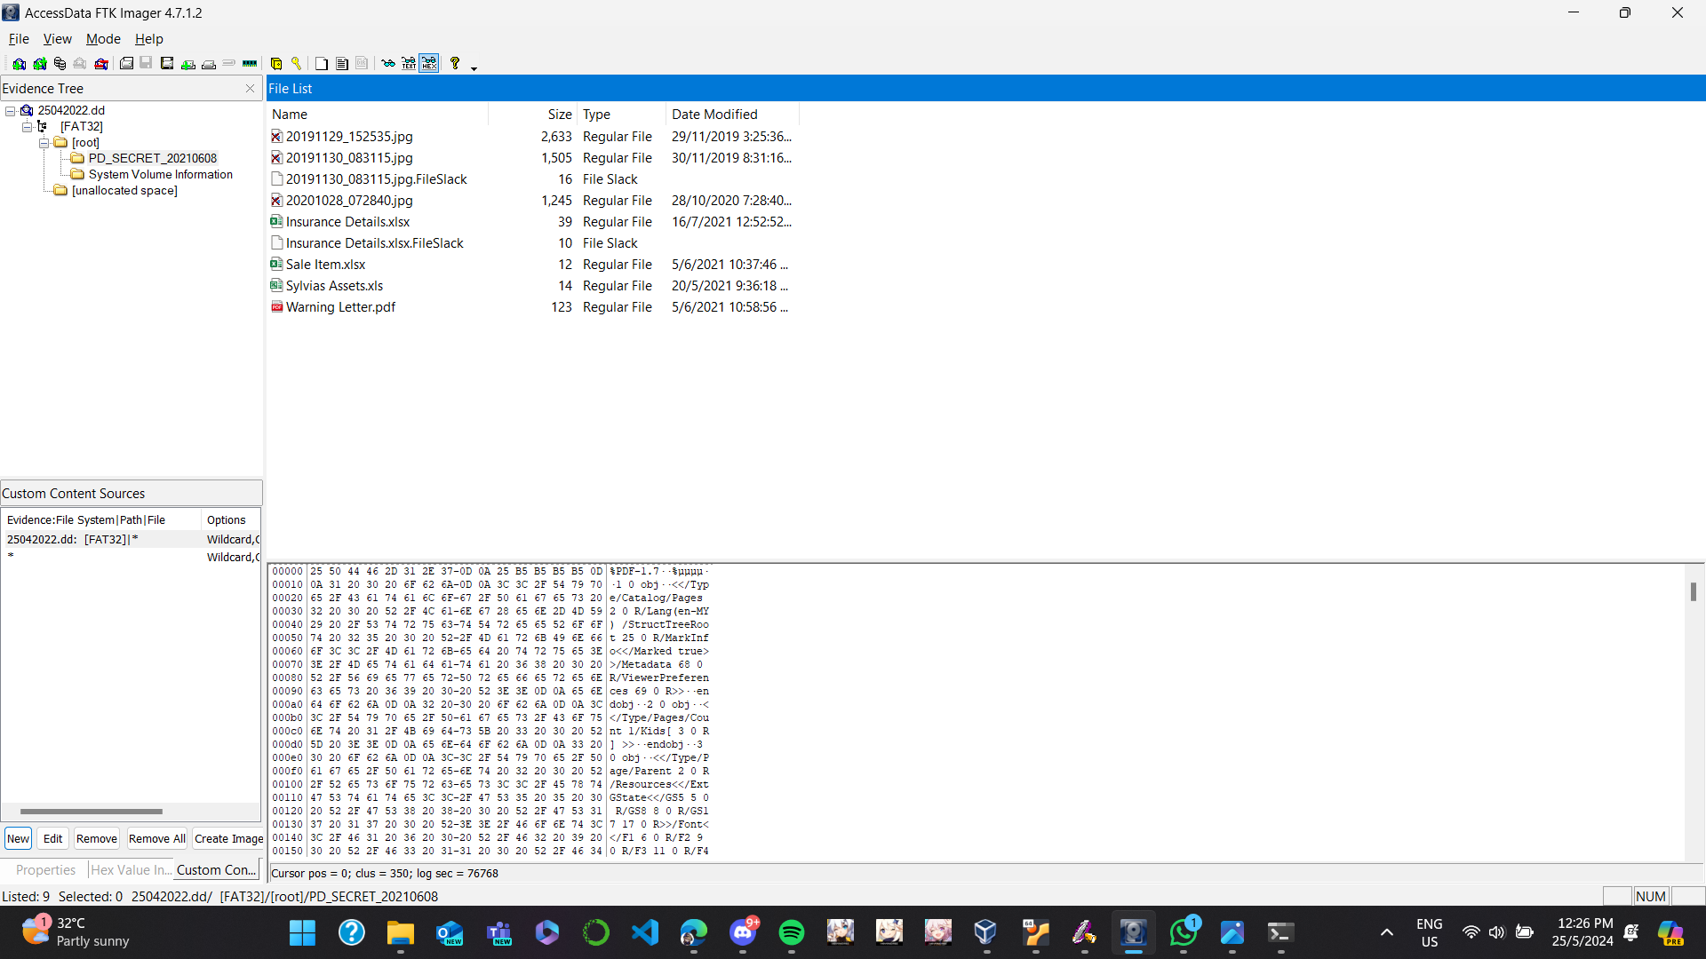

Put DD file in forensics tool such Ftk Imager and we can found a pdf file warning letter



Run it using certufil found it hash which is the flag

Misc

Apa benda ni Mat

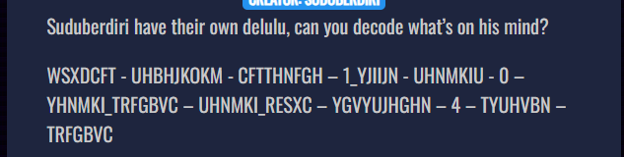

the question give this gibberish like text and a clue which is link that go to picture of keyboard

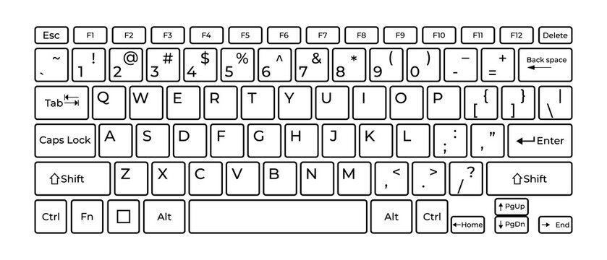



So by this patter now we know the flag is MIIT2024{WHA1_YO0U_SO_CR4ZS}

Network

Help me

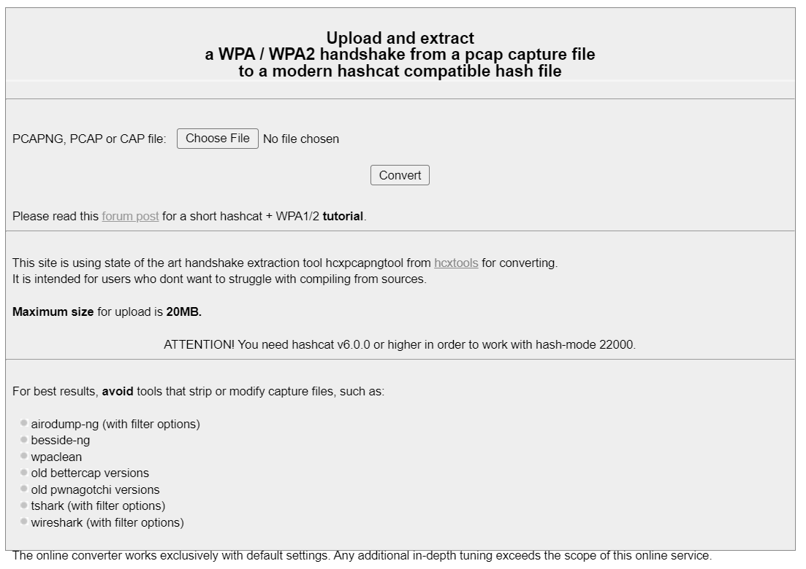

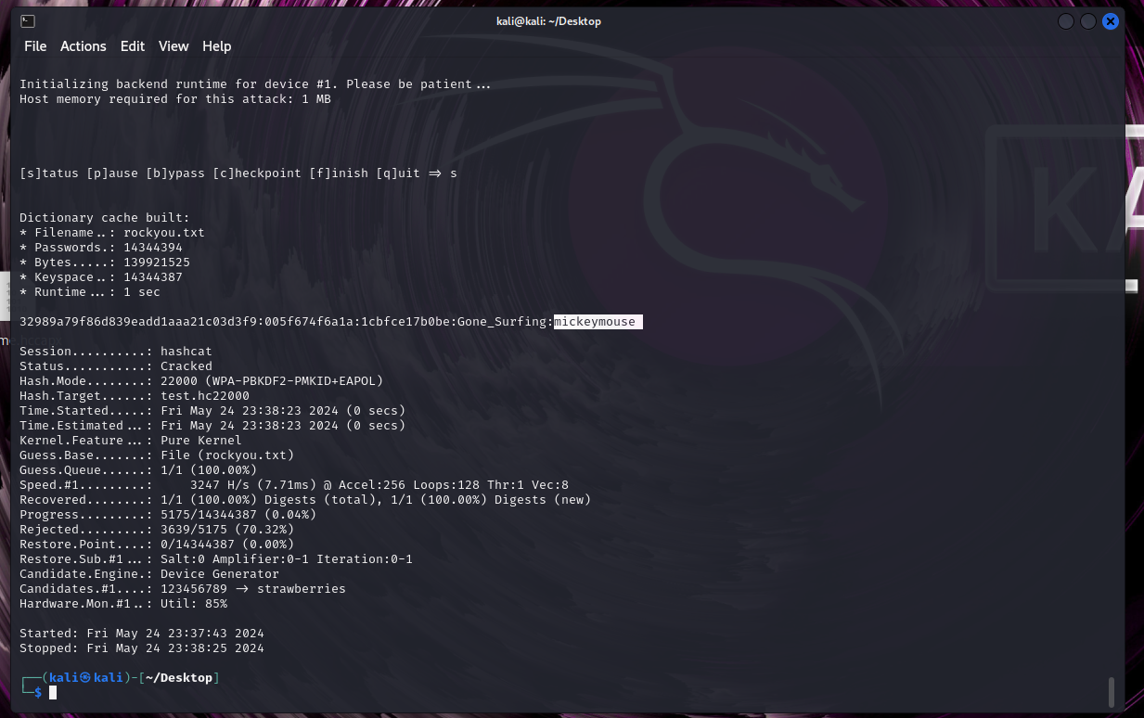

Nice Dorm

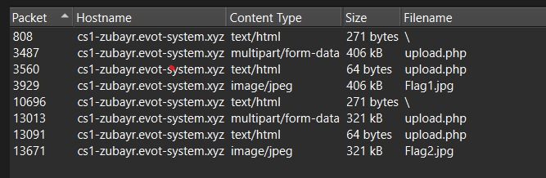

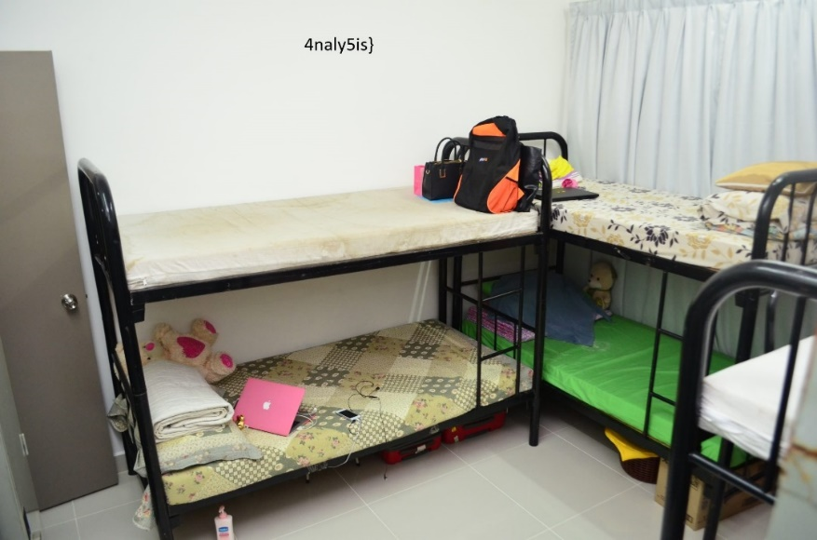

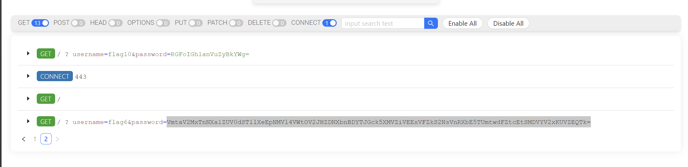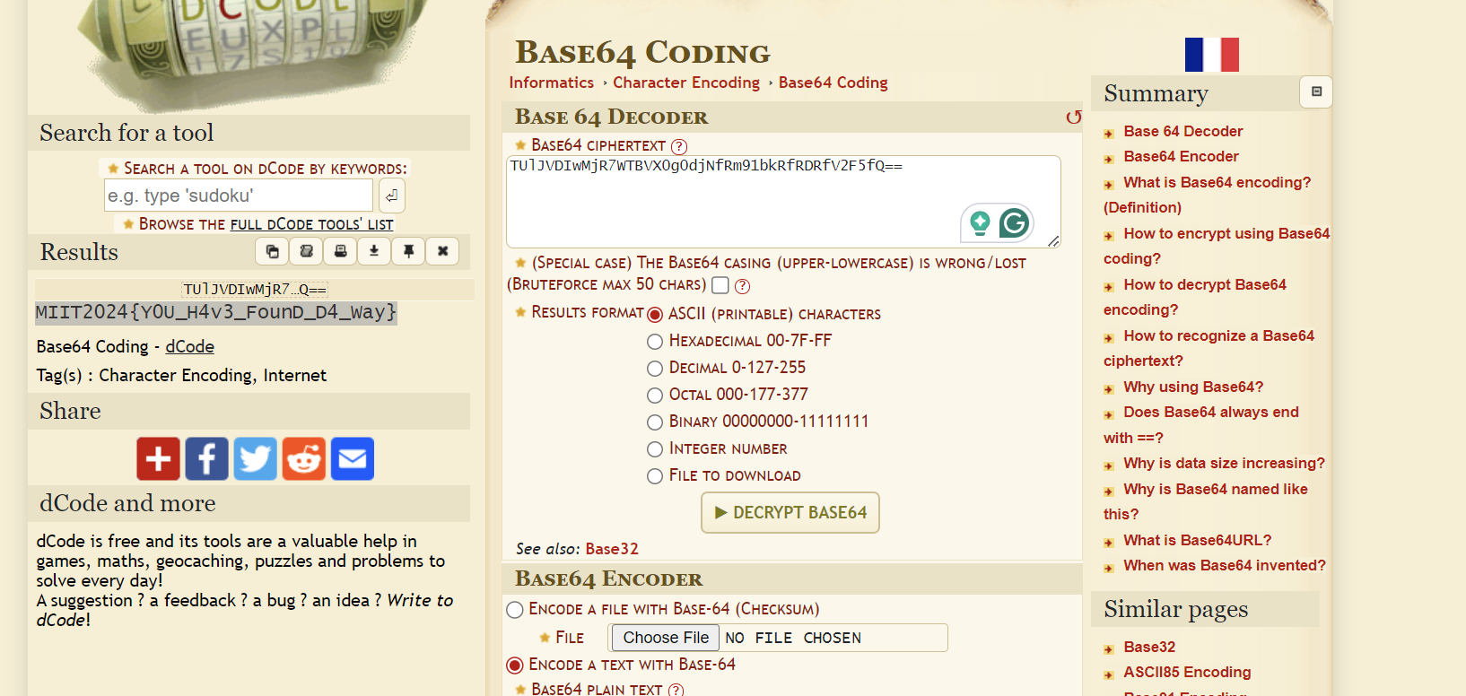

Just decode it many times

Web

SpecialAgent

Based on the hint given which is user agent, I tried to use curl commands and found out the undefined array key on ‘HTTP-USER AGENT’

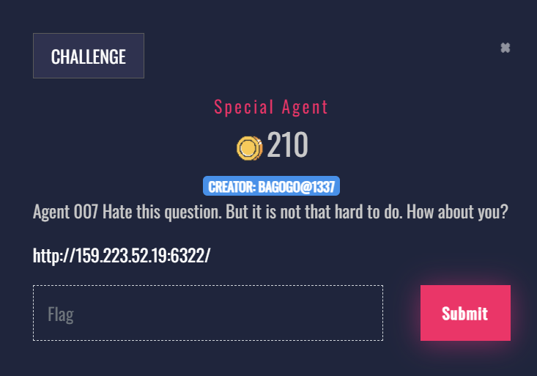

After curl it get base64 code and decode it

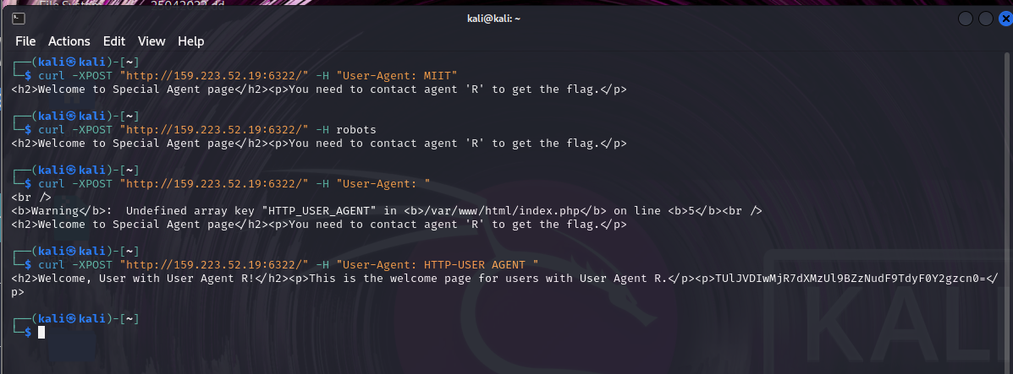

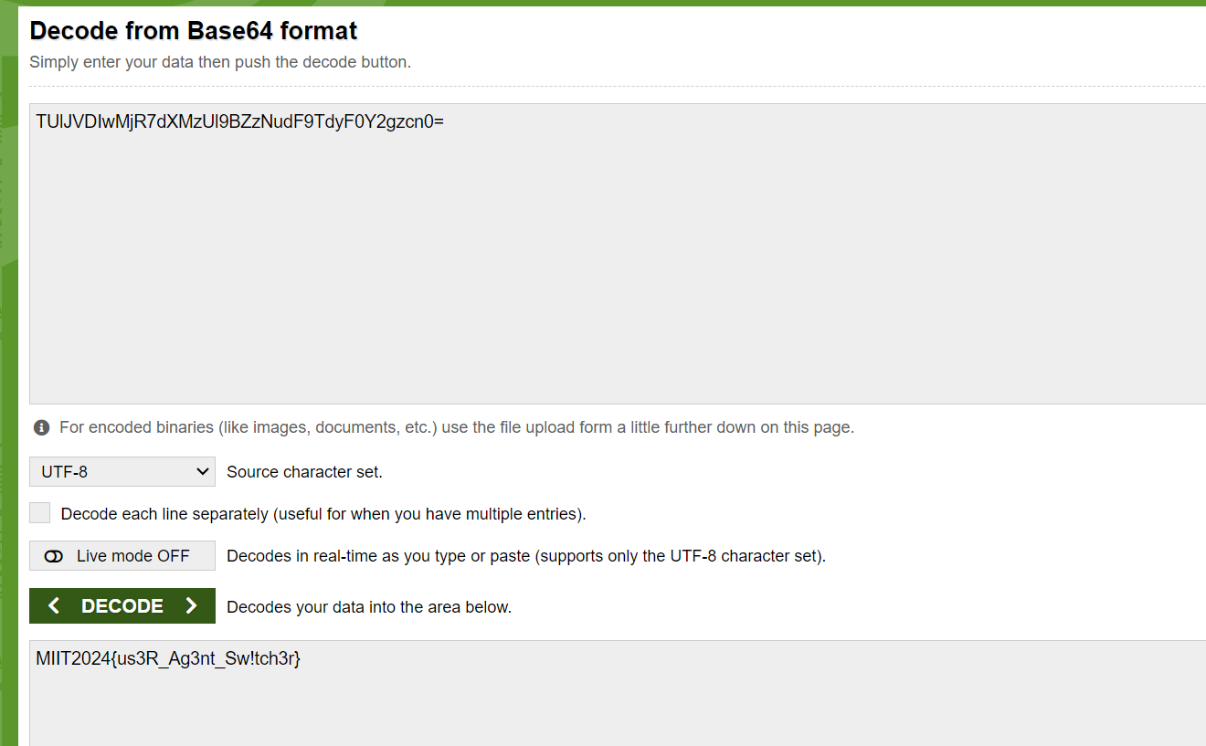

Source Code Review1

Open the link given and it direct to a website.

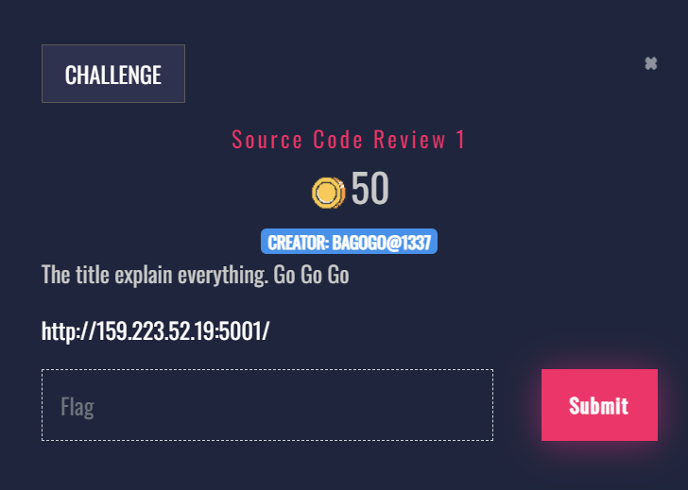

View the source code and found out that suspicious comment. I try to decode on spammimic and get the output

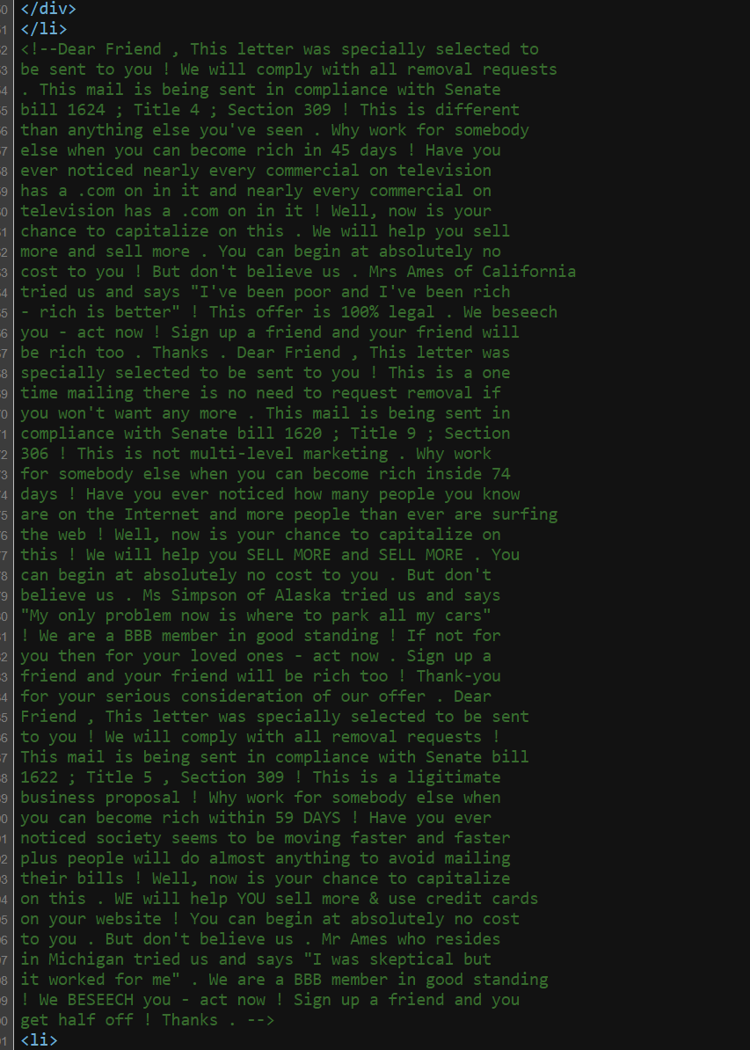

Flag tester

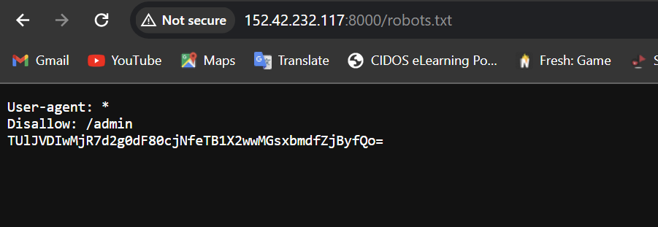

Osint

Clone

-Based on instagram emirulevil, we can see that the picture show subway and the hint is danau kota. I see primavalet store and search near danau kota. Find out that it on Wangsa walk,  
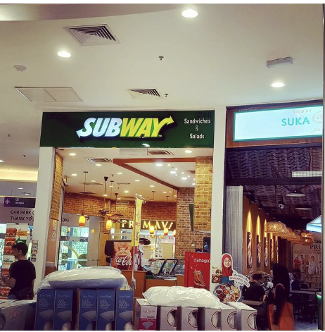

Based on the hint, its address and get

MIITCTF2024{WangsaWalk_Jalan_Wangsa}

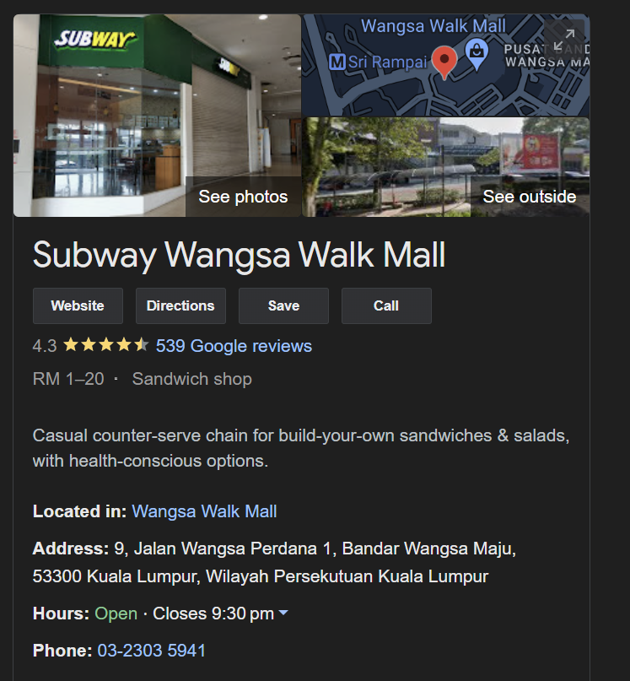

PastWorld

After get Alternateworld question, I checked on the reddit profile. Found out a link to https://plnsgr.github.io/os1ris/.

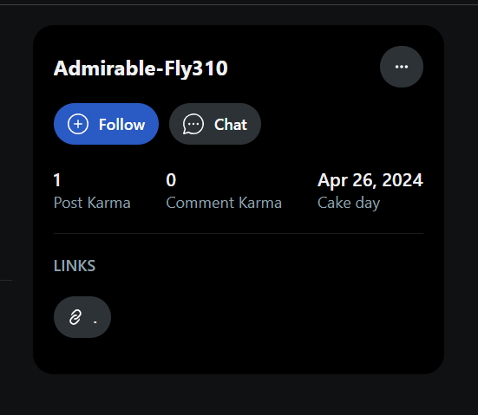

Scroll down and we can see base64, copy and decode it

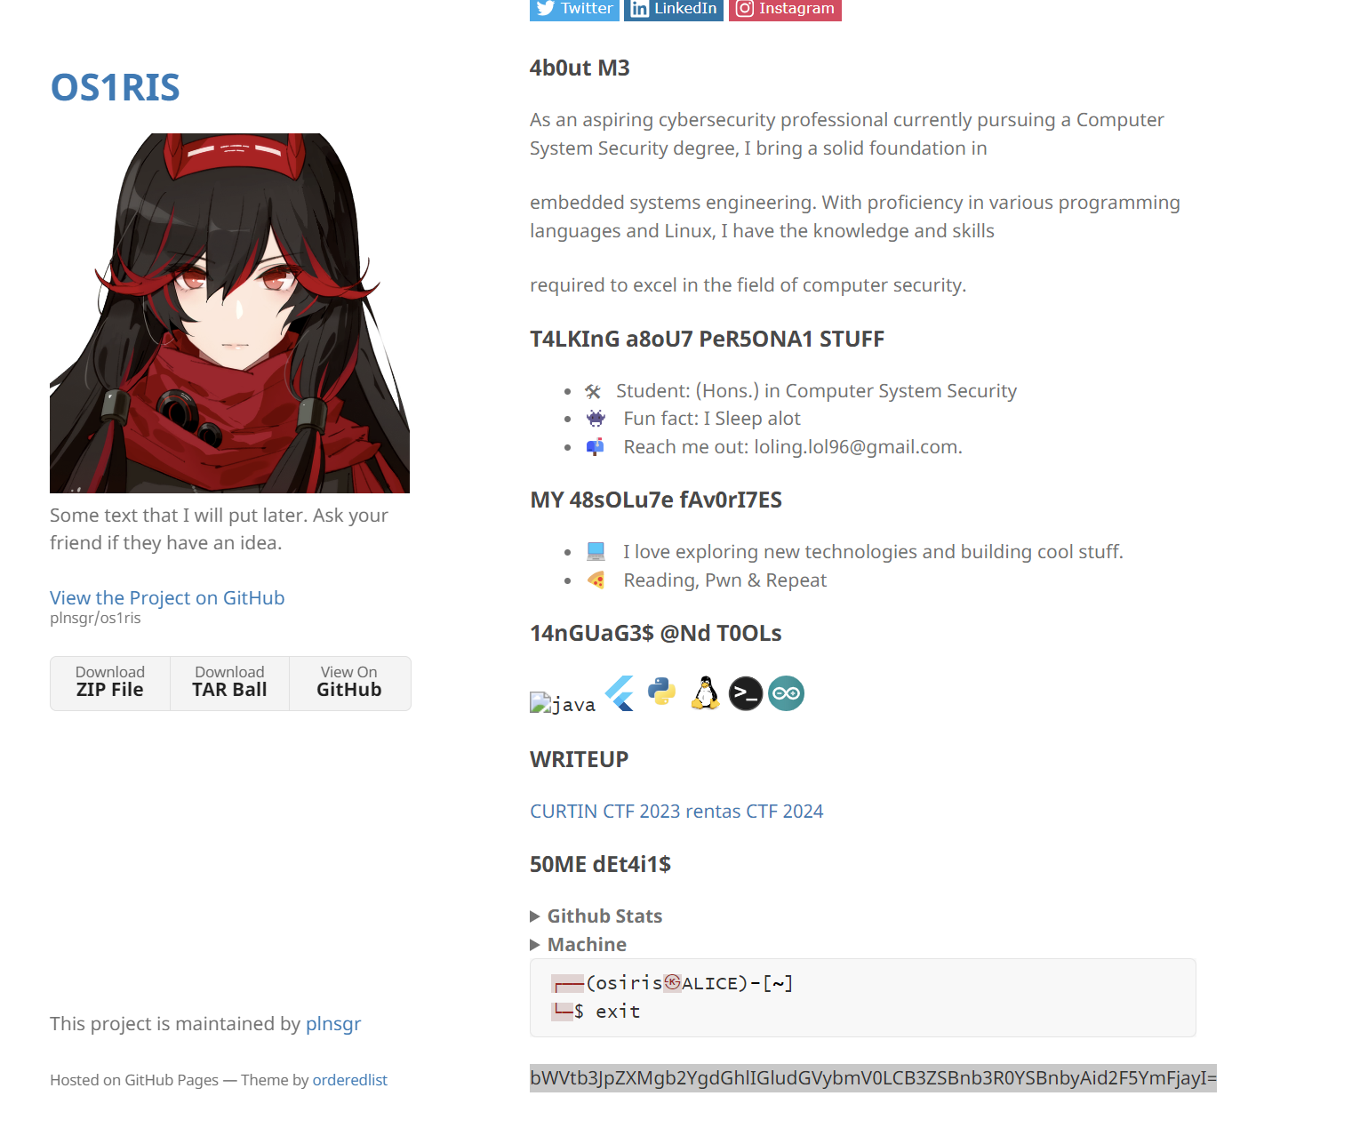

The hint given is memories and wayback. We can use wayback machine to see internet archive.

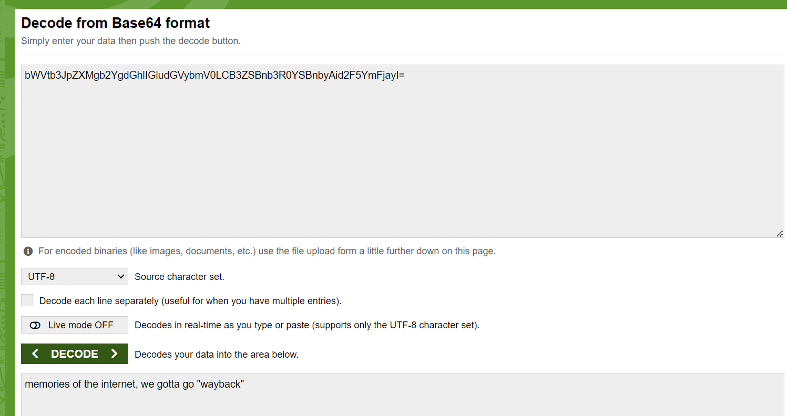

Found out another base64 and decode it.

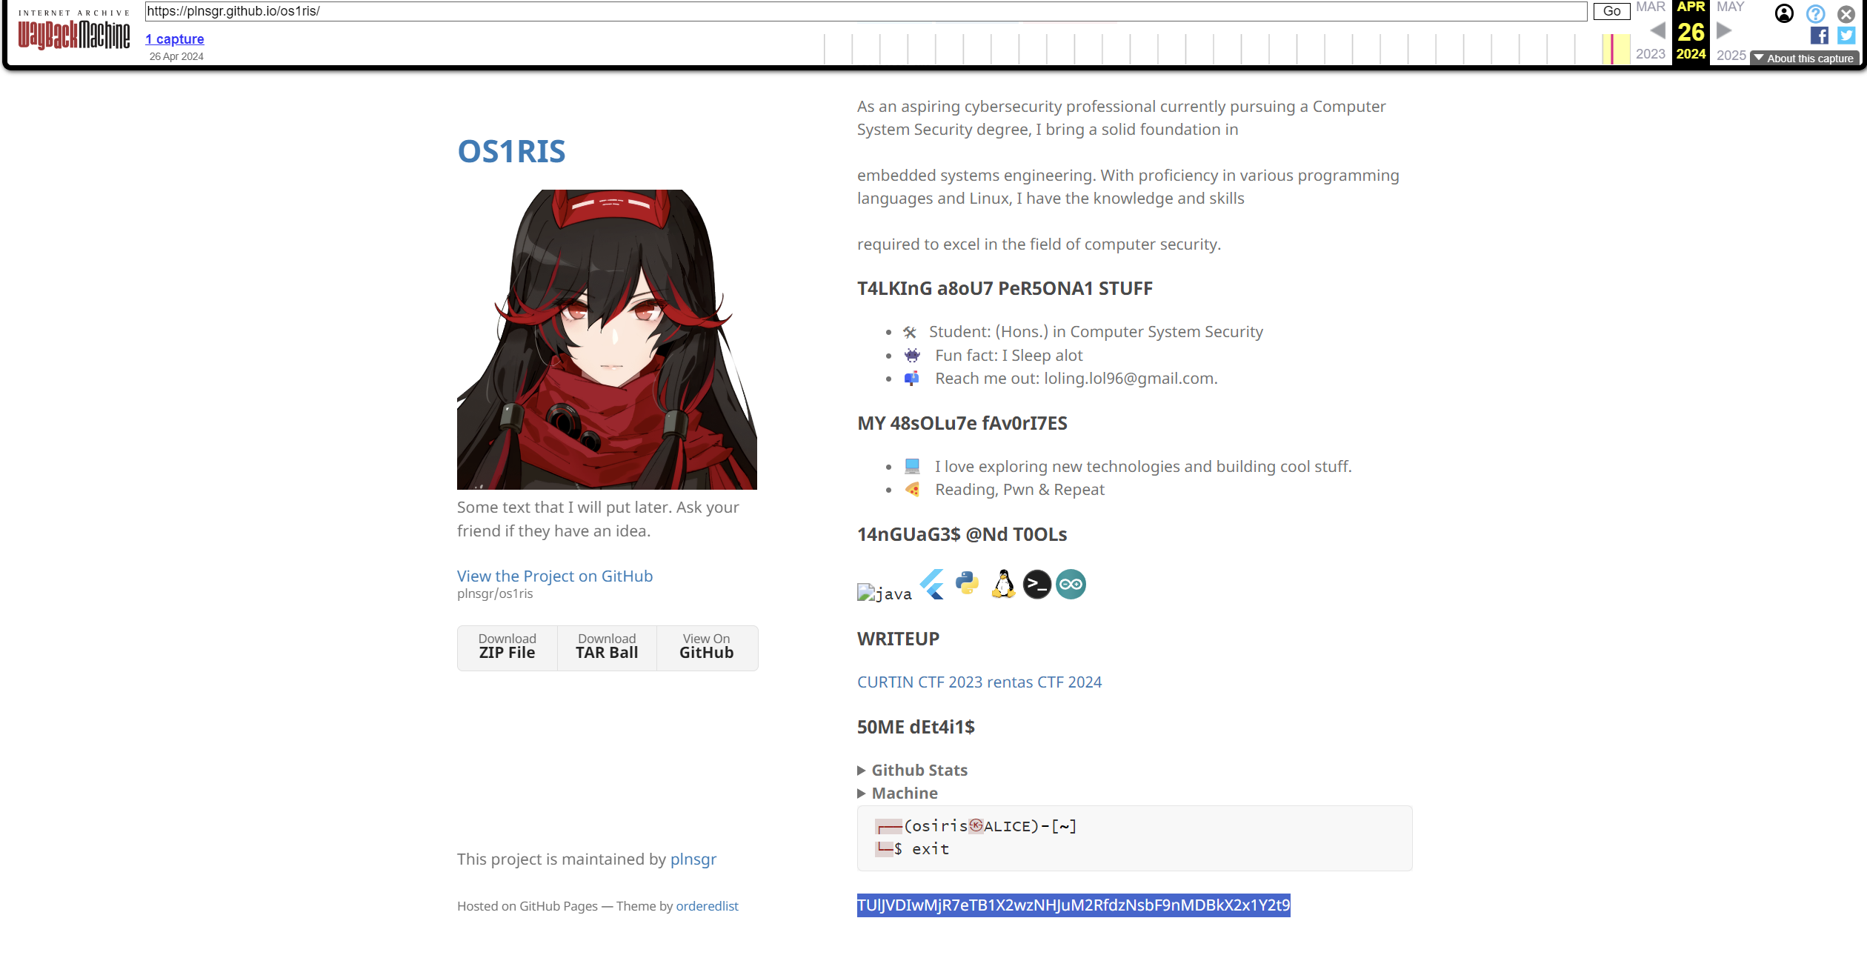

And get the flag

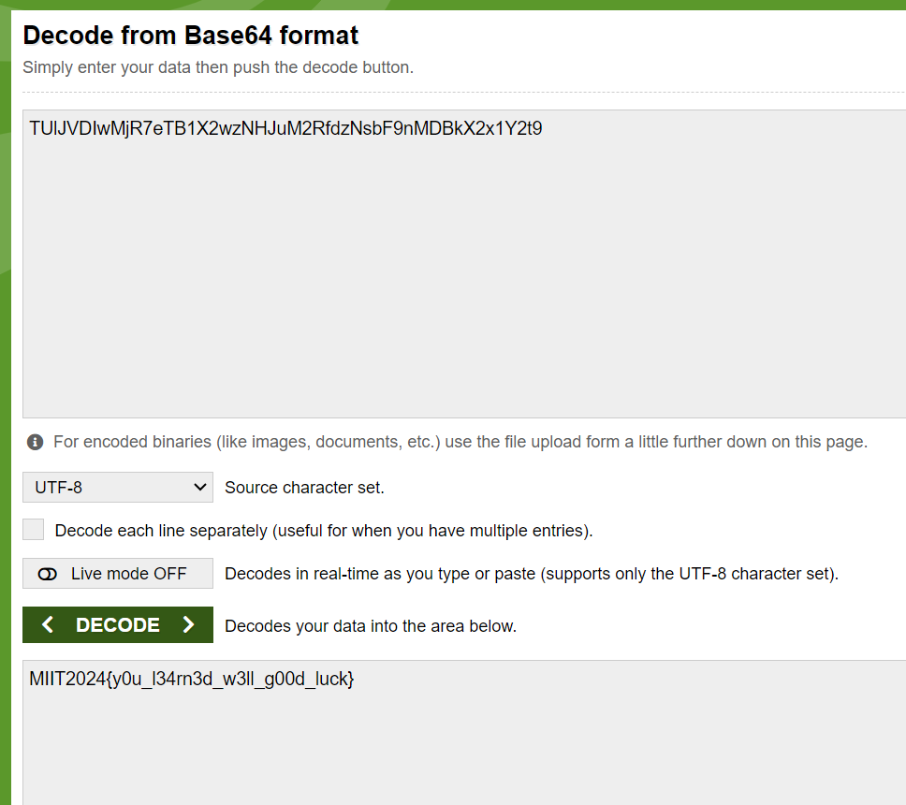

Illusion world

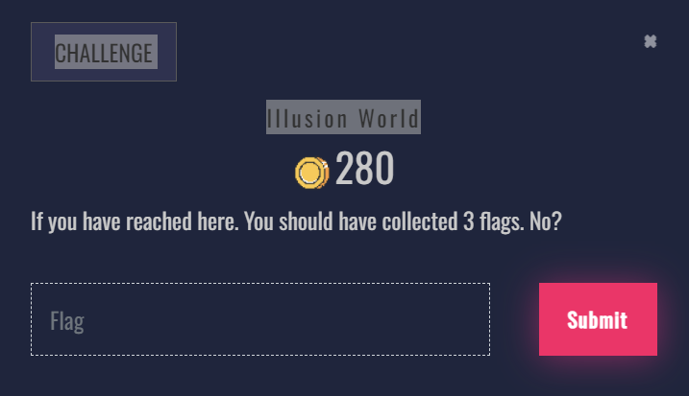

After get the 3 flags, then I see the twitter have 50 post. I just scroll down to see and found the flag.

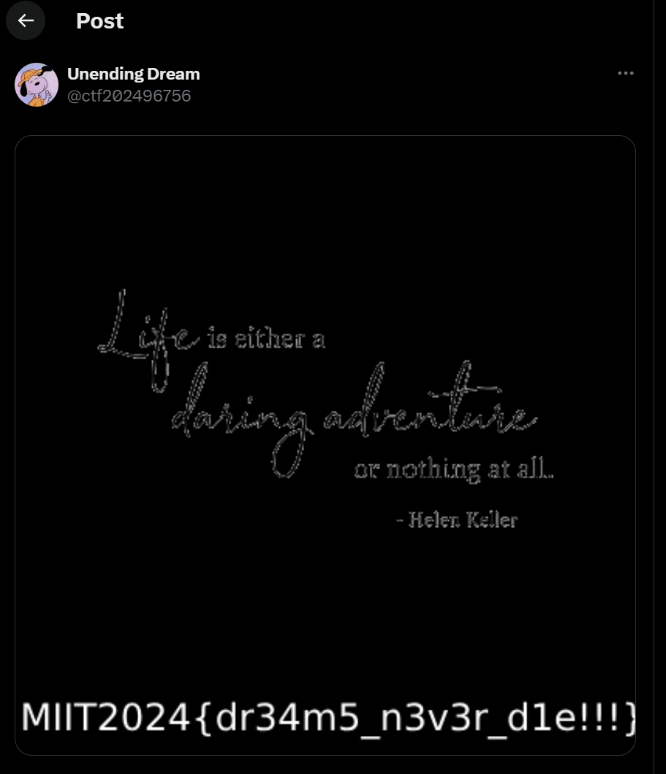

Bonus

